N E W S R E L E A S E

Client: Walt Denny Inc.
Description: Internet PR campaigns
Project: 09-WD-014
For Release: Immediately
Contact: Mary Lou Denny, marylou@waltdenny.com

Gain Fast, Impactful Brand-building through Internet PR
Taking a public relations strategy to the web is one of the most cost-effective and far-reaching ways for an organization to build its brand and create real-time impact. Progressive companies recognize the wealth of Internet public relations opportunities and take targeted steps to gain a dramatic increase in brand visibility. PR on the web surpasses print and broadcast PR because its content capacity is limitless. Exposure is enhanced when web users redistribute what they view as important information.
With useful, stimulating content presentations, Internet users are drawn to see the benefits of a company and its products and services. Whether it’s a press release posted to a web site, an update to a company’s "about us" page, a product demonstration video or a daily blog post, content needs to be engaging to achieve the desired results.
The more quality content an organization generates, the more likely it is to be retrieved among critical top search results; and the more likely it is to be viewed by those interested in the content who may multiply the effect by writing subsequent articles or posts, or forwarding the content.
The following tools are considerations for any successful Internet PR campaign:
Email newsletters
The ever-popular email newsletter is a very effective way to stay top of mind with customers and prospects. Whether an opt-in newsletter is emailed weekly or monthly, this communication lets people know about the latest developments with an organization, from new products to sales records to high-profile exposure in a national publication. The nature of opting in means that each reader has a declared interest in the email. Jupiter Research found that more than 1 out of every 4 emails is an opt-in email. The information flow builds trust, and can even help customers generate increased profitability with marketing ideas.
News Releases
No PR strategy can be complete without news releases. Online, the hunger for fresh, relevant news is present around the clock. A well-written news release provides interesting, informative and timely turnkey content that increases value for the brand, and increases valuable utility for web editors. The content will also resonate with the information’s end-user.
Southwest Airlines found that by optimizing its press releases for online search engines, it could see a large multi-day sales spike after each optimized press release. The airline was able to directly link seven releases spread over a 15-month period to $2.5 million in online ticket sales.
Blogs
Like email newsletters, blogs are a supremely effective way to keep in touch with customers, suppliers and distributors. They also enhance brand credibility and build excitement. The capacity for readers to comment to blog posts, and for bloggers to respond, fosters meaningful and open two-way communication. While the frequency of blogging can vary from a couple times a day to a few times a week, it’s a forum that allows dynamic information-sharing on industry happenings, trade shows and important articles. In 2008, the Pew Internet & American Life Project found that 24% of adults read blogs, while a JupiterResearch survey found that 50% of online consumers find blogs useful for purchase information.
RSS
By promoting RSS feeds (Really Simple Syndication), a blog or website allows readers to "subscribe" to content updates so they automatically receive notice via email or "feed-reader" when there's new information. The utility of RSS goes both ways; an organization should also be using RSS feeds to stay on top of its industry and competition - this provides the company more opportunities to make its own contributions to dialogues, thereby increasing its visibility and strengthening its role as an industry leader.
Social Networking
The popularity of social networking via sites such as Linked-In, Twitter and Facebook continues its meteoric rise. This networking grants a company the ability to constantly see and be seen; new contacts can be made and information exchanged through growing networks. Research firm Forrester found that among adult web users in 2008, those reached by social media increased from 56% to 75%. With social networking, a company can immediately post about events, such as a new product unveiling or a seminar. Customers and prospects can even be invited in real time to visit a booth as they walk through a trade show.
Video & Podcasts
Broadcasts via the web produce attention-getting exposure, and can be promoted via the tools mentioned above. Video on the web can include how-to instructions, product demonstrations and customer case studies. Audio may include a company’s analysis on the latest trends in its industry, trade-show interviews with customers, or a regular recap of company current events.
Media Relations
Companies that work closely with web editors can become trusted, sought-out sources for the editors’ sites. By staying in touch and letting editors know about the availability of sources, digital news release copy and images, and video and podcasts, businesses with a great online presence and PR strategy can help editors simplify their information-gathering. Editors seek to battle stagnation with high-quality, continuously updated content. Companies not only need to keep in touch with these influential professionals, they need to be familiar with their content needs and monitor the coverage and blogs of the website.
Online Communities
The complete range of tools mentioned can be implemented into an online community. Actionable user feedback is a key benefit, along with improved visibility; research by Deloitte found that businesses with an online community saw a 35% increase in word of mouth for their brands. Interest-generating components can include poll questions and photo galleries featuring products in use, or images from trade show events.
An Internet PR strategy is critical for every public relations campaign. An experienced public relations firm can help deliver a distinct edge in making the most out of online opportunities and standing out among the millions of web pages that continue to be created. The most successful web strategies are comprehensive, can be quickly implemented, and boost brand awareness with immediate impact.

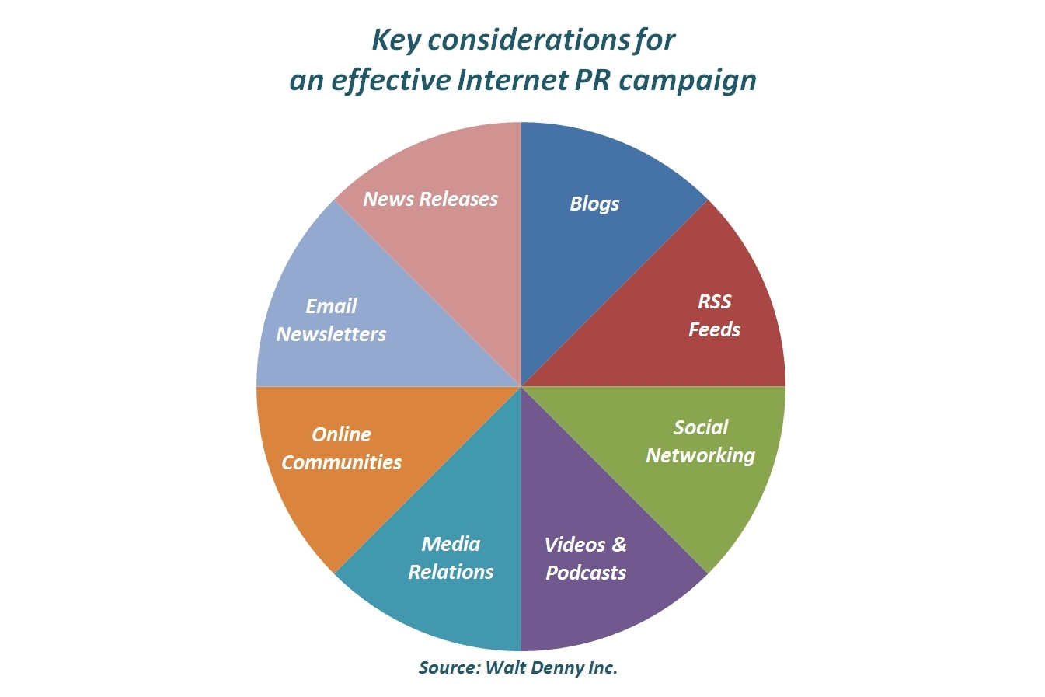Click here to download this image.

For more information, email walt@waltdenny.com, or call 630-323-0555. Since its founding in 1989, Walt Denny Inc., a full service public relations and advertising agency, has been The Home Products Agency™, working with a national client base and building each organization’s positive brand awareness through bold results and individualized strategies. Client experience includes industry-leading organizations such as Whirlpool, KitchenAid, HomeCrest Cabinetry, Royal Outdoor Products, The Tapco Group, Johnson Hardware, Amerock, a division of Newell-Rubbermaid, Leaders Bank, and Aaron Equipment.
# # #

